|  |
| --- |
| **Final Report** |



|  |  |  |  |
| --- | --- | --- | --- |
| 제출일 | 2020.07.02 | 전공 | 소프트웨어학과 |
| 학번 | 201635827, 201635832  201635848, 201835462 | 이름 | 오태호, 이상운,  장휘준, 박해원 |

**Contents**

1. Introduction

2. User requirements

3. System requirements

4. System modeling

5. Architecture

6. System implementation

7. System Testing

**1. Introduction**

This application is used to reserve a reading room or library seat. Users can reserve seats by selecting the reading room or library to use and entering the seats they want to use and the times they want to use them. Also, time can be extended through extension and out-of-office functions. The number of use of these functions is limited to one time.

**2. User requirements**

**Functional requirements**

<Create Account>

* Enter user’s name, student number, college, phone number, email, and password.
* The information is essential to enable seat reservations for each user.

<Login>

* Enter user’s email and password.
* The information is used to identify which users.
* If you confirm that you are a user registered with our application and who you are, you can use the application service.
* Because administrators and users have different permissions, logins are divided into two groups.

<Reservation>

* User wants to reserve a seat in the reading room or library.
* Enter the reading room or library to use, and the seats and time to use.
* The seats are reserved according to the information entered by the user.
* If the seat you want to use is one that is being used by another user, you cannot reserve that seat.
* If the seat that the user wants to reserve is already in use, the seat should not be clickable.

<Extension>

* Select the time they wish to extend.
* The seat reservation time is extended by the user's input time.
* The system limits the amount of time that can be selected.
* The number of uses is limited to one because of the possibility of abuse.

<Out-Of-Office>

* Select the time they wish to go out.
* The seat reservation time is extended by the user's input time.
* The system limits the amount of time that can be selected.
* The number of uses is limited to one because of the possibility of abuse.

<Check-Out>

* Click the checkout button.
* The seats that the user was using will be checked out, allowing others to make reservations.

<Set Time(Admin)>

* If the manager wants to increase or decrease the hours of use of the reading room or library, click the Extend button or Decrease button.
* Each press of the button increases or decreases the usage time by one hour.

<Check-out(Admin)>

* Select the reading room or library with the seat you want to check out and click on that seat.
* The seat chosen by the manager will be checked out, and the seat can be reserved by others.

**Non-functional requirements(Product requirements)**

<Usability requirements>

* UI should be shown by function so that users can easily use them.
* In order to give the user a quick, at-a-glance view of the available seats, the seats in use should be distinguished by their colors.
* The UI should be well set up so that new users can see at a glance what the features are even if they use it.

<Reliability requirements>

* Users must specify their colleges precisely to reserve seats in their reading rooms.
* In order to confirm that the seat is yourself at the time of booking, the information required at the time of signing up must be filled out.

<Performance requirements>

* The seats in use should be displayed in the UI within one second to enable the user to quickly identify available seats.
* When using functions such as reservation, extension, or outing, check-out, the time to update user information and store it in the DB shall be within two to three seconds.
* When the user uses the My Seat menu, it should take less than a second to retrieve the user's information from the User DB and display it to the user.

**Non-functional requirements(Organizational requirements)**

<Operational requirements>

* To use the Gachon University reading room and library, you must create an account in the application and reserve a seat through that account.
* Students who use the application provide personal information such as their name, student number, and college, which identifies users in the application.
* Students of the student council are appointed as managers and have their seats reserved in the reading room during the exam period and cancel seats for those who are not in use.

**Non-functional requirements(External requirements)**

<Accounting requirements>

* When personal information is found to have been leaked pursuant to Article 34 of the Personal Information Protection Act, it shall be notified to the relevant information subject without delay.

<Safety requirements>

* If the user has no access history for six months from the last time the application was used, discard the user's information.

<Ethical requirements>

* The manager should not use the force check-out function for malicious purposes.

**3. System requirements**

**Functional requirements**

* The user’s information should be entered.
* We should store user’s name, student number, college, phone number, email, and password.
* The information is stored in the DB and accesses this information at login to verify the email and password.
* When logging in, the ID and password should be checked in the DB and logged in only if it is correct.
* The seat reservation function is a function in which a particular person uses a seat for a certain period of time.
* If you log in without proper verification, a user may book multiple seats.
* Seats reserved by the user should have status information changed and stored it in DB.
* Use the status information stored in the DB to indicate available seats.
* If the status information does not change, the same seat can be booked multiple times.
* When a user books a seat, the user information must be updated and stored in the DB.
* My Seat menu takes the information from the user DB and shows it.
* If the information is not updated and stored in the DB, the correct information cannot be shown.
* If the information is not updated and stored in the DB, a user will be able to reserve multiple seats.
* Once the extension and out-of-office functions have been used, the information should be remembered.
* Extensions and outings could be abused, so they are allowed to be used only once in the system.
* If the information is not remembered, one user can use unlimited extension and out-of-office functions.
* This makes it possible for one person to use the seat forever.
* If the user has checked out, the user's information should be updated and stored in the DB.
* My Seat menu takes the information from the user DB and shows it.
* If the information is not updated and stored in the DB, the correct information cannot be shown.
* If the information is not updated and stored in the DB, the user can no longer book any seats.
* If the user has checked out, the status information of the seat shall be updated and stored in the DB.
* When the user makes a reservation, the application shows the available seats by referring to the status information in the seat DB.
* If the status information is updated and not stored in the DB, the seat cannot be booked continuously by anyone.
* If the manager has checked out a particular seat, the status information for that seat should be updated and stored in the DB.
* When the user makes a reservation, the application shows the available seats by referring to the status information in the seat DB.
* If the status information is updated and not stored in the DB, the seat cannot be booked continuously by anyone.
* If the manager has checked out a particular seat, the information of the user who was using the seat should be updated and stored in the DB.
* My Seat menu takes the information from the user DB and shows it.
* If the information is not updated and stored in the DB, the correct information cannot be shown.
* If the information is not updated and stored in the DB, the user can no longer book any seats.

**Nonfunctional requirements(Product Requirements)**

* <Usability Requirements>
* Use a application as the system interface.
* Only support Korean
* <Reliability Requirements>
* All functions provided by this application are available only to users who subscribe to the application.
* The rights of general users and administrators should be set differently.
* The service shall continue to be provided within the available hours of the reading room or library set by the manager.
* User information or seat information should not be deleted even if an error occurs in the application.
* User information, manager information, and seat information should be stored accurately in the DB.
* <Performance Requirements>
* When a user makes a reservation, the time to save to the DB after changing the user information should not be more than 2 seconds.
* When the user makes a reservation, the time to be stored in the DB after changing the seat status information shall not be more than 2 seconds.
* When a user requests extension or outing, the selected time shall be extended and stored in the DB within 3 seconds.
* When a user requests a check-out, the user information must be changed and stored in the DB within 2 seconds.
* When the user requests a check-out, the seat status information must be changed and stored in the DB within 2 seconds.
* When a manager checks out a particular seat, the time to modify the status information of that seat and store it in the DB shall not be more than 2 seconds.
* When a manager checks out a particular seat, the time to modify the user information that was using that seat and store it in the DB should not be more than 3 seconds.

**Nonfunctional requirements(Organizational Requirements)**

<Operational Requirements>

* Since the app is used for reading rooms and libraries at Gachon University, the main functions are written similarly to the existing Gachon University seating reservation system.
* We need additional features added to the existing Gachon University seating reservation system.
* By adding out-of-office functions, we can reduce the waste of time caused by unavoidable circumstances.
* Add manager functions so that seats can be used efficiently by multiple people.
* Manager functions include compulsory check-out, adjustment of the hours available to reading rooms and libraries.
* The existing Gachon University seat reservation system is limited to the library, which allows efficient reading room management by extending the scope to the reading room.

<Development Requirements>

* It is a Java-based application because it uses an Android Studio.
* UI is built on XML because it uses Android Studio.
* Use Firebase as a database.
* Github was used to share and collaborate code written to each other.

**Nonfunctional requirements(External Requirements)**

<Accounting Requirements>

* All information used in this application should be stored in the DB or referred to in the DB and the DB should be managed efficiently.
* If an open source is used to prepare the system, the source of the open source used must be identified.

<Safety Requirements>

* All the information used in the application is stored in the DB.
* When storing information, proceed by storing all the information in the central DB.
* Personal information should be encrypted and stored in the DB.

<Ethical Requirements>

* Reading rooms at each college should only be used by students belonging to that college.
* People other than Gachon University students should not use reading rooms.

**4. System modeling**

**Scenario**

* If the user has not yet signed up for the application, sign up as a member.
* Administrators log in to the application as administrator logins and end users log in to the application as user logins.
* The user selects the reading room or library he or she wants to use.
* The seats you are using appear black, except for these seats, select the seats you wish to use.
* Select the time you want to use.
* The reservation has been completed and a message appears that the reservation has been completed.
* You can check your reservation information by selecting the My Seat menu.
* If you want to extend your seat use time, click the Extend button on My Seat menu.
* Select the time you want to extend.
* A message appears indicating that the extension has been completed and the extended time applies to My Seat menu.
* If the user have already extended it once, clicking the Extend button displays a message that the user cannot extend it.
* If you have a situation where you have to go out, click the Outing button in my seat menu.
* Select the time you want to go out.
* The amount of time to go out appears in the message and the amount of time is extended to apply to My Seat menu.
* If the user have already used outing function once, clicking the Outing button displays a message that the user cannot use outing function.
* If you want to check out, click the check-out button on My Seat menu.
* All the information displayed in My Seat menu will be initialized and the seats used by the user can be reserved by others.
* If the manager wants to extend the hours available to the reading room or library, click the Set Time menu.
* The default time is set to 18:00.
* If the manager press the extension button, the manager will be asked if the manager wants to extend it by one hour, and if the manager press OK, the available time will be extended by one hour.
* If the manager wants to reduce the hours available to the reading room or library, click the Set Time menu.
* The default time is set to 18:00.
* If the manager press the reduction button, the manager will be asked if the manager wants to reduce it by one hour, and if the manager press OK, the available time will be reduced by one hour.
* If the manager wants to set the availability time of the reading room or library back to 18:00 which is the default time, click the Set Time menu.
* If the manager clicks the reset button, return the available time to 18:00.
* If the manager wants to check out a particular seat, he or she chooses the corresponding reading room or library for that seat.
* Click the seat the manager wants to check out.
* A message appears asking if the manager wants to check out the seat, and pressing OK will check it out and other users will be able to book the seat.

**Model**

**<Class diagram>**

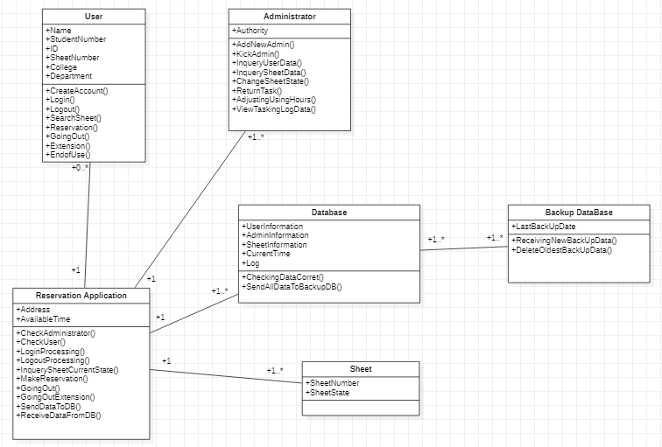

**<Use case Diagram>**

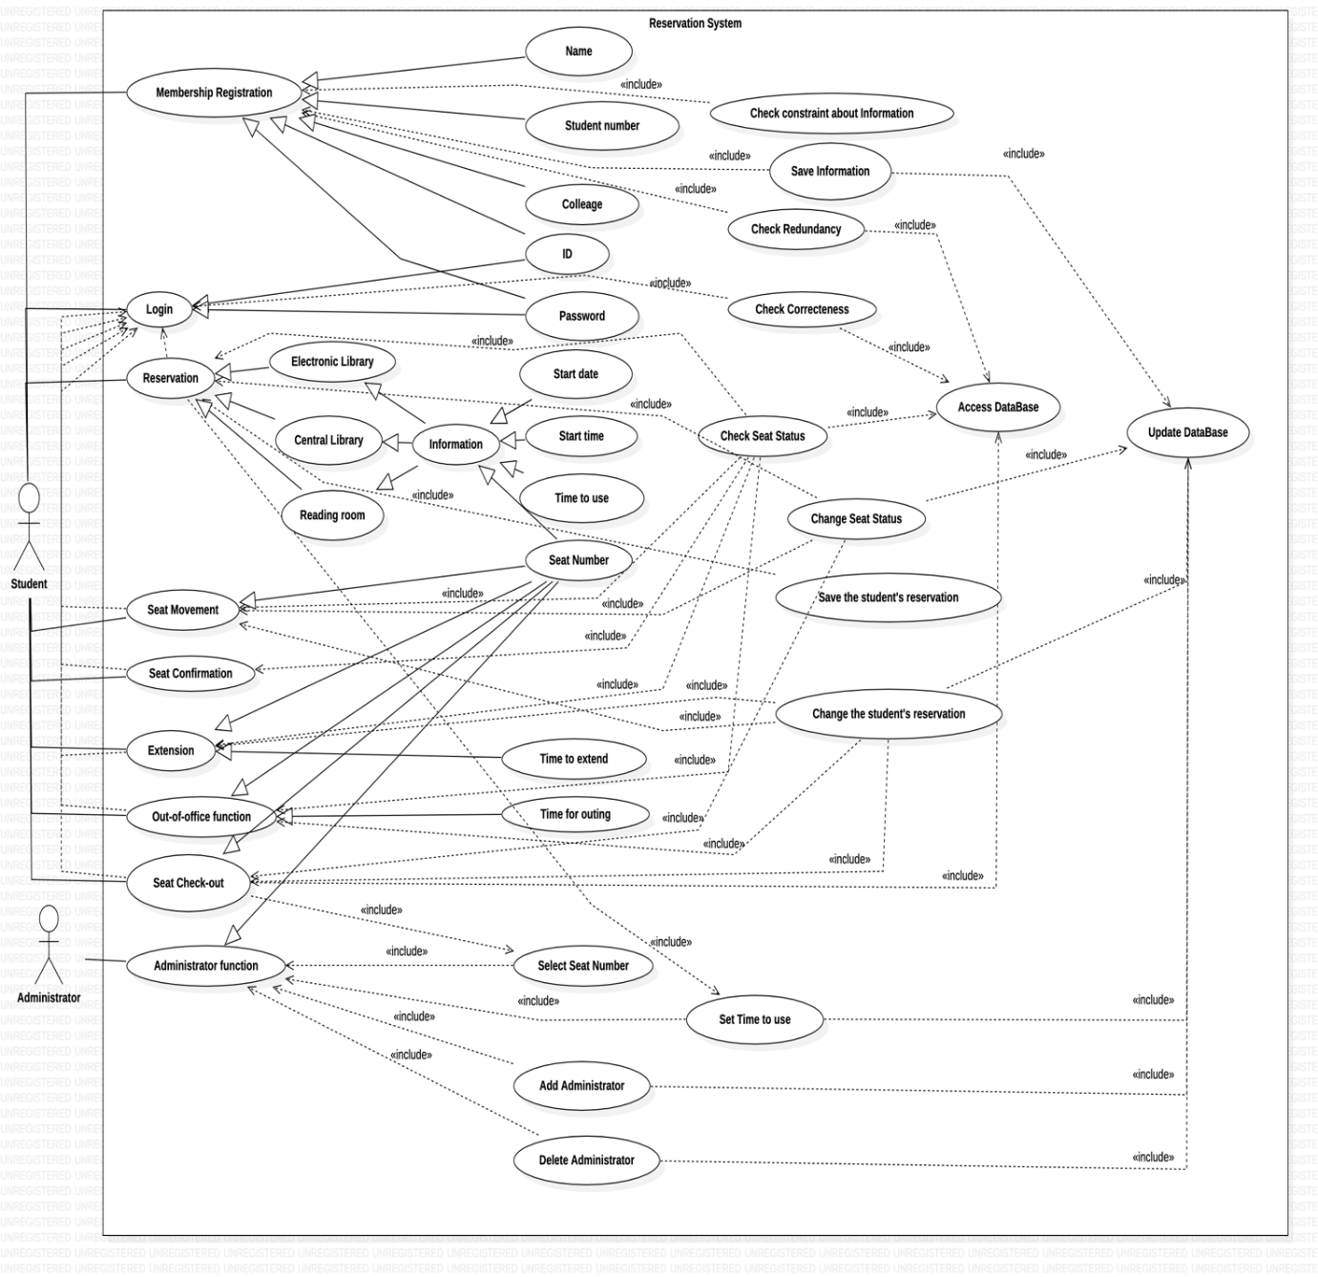

**<State Diagram>**

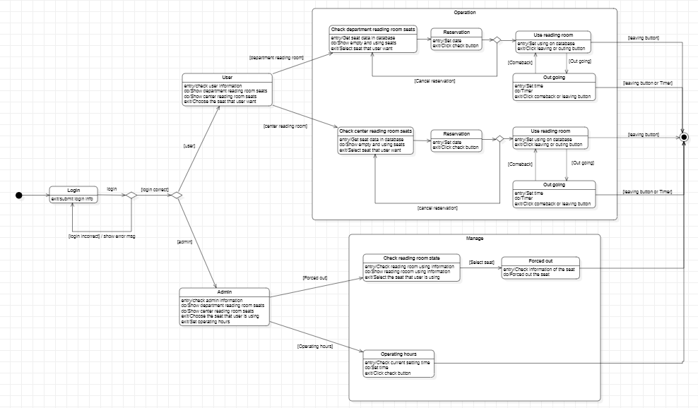

**Sequence Diagram**

**<Reservation>**

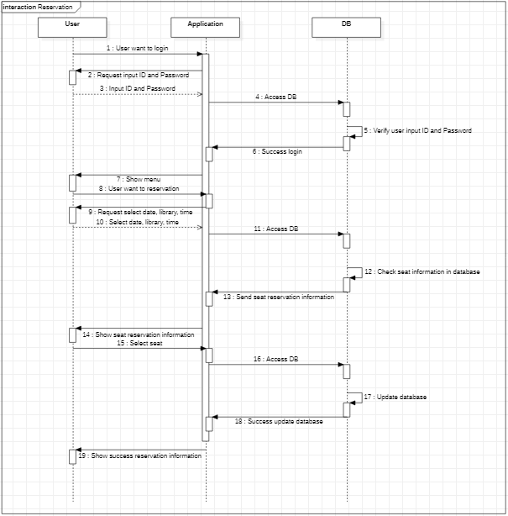

**<Extension>**

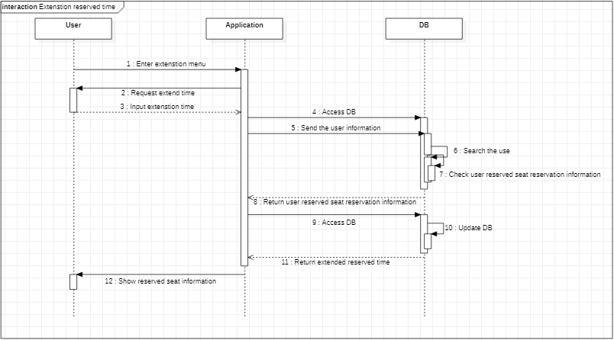

**<Out-Of-Office>**

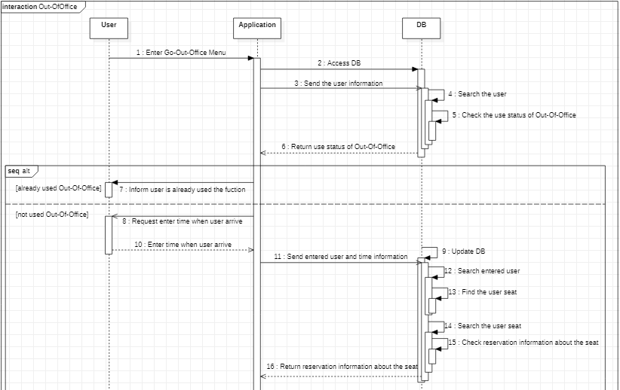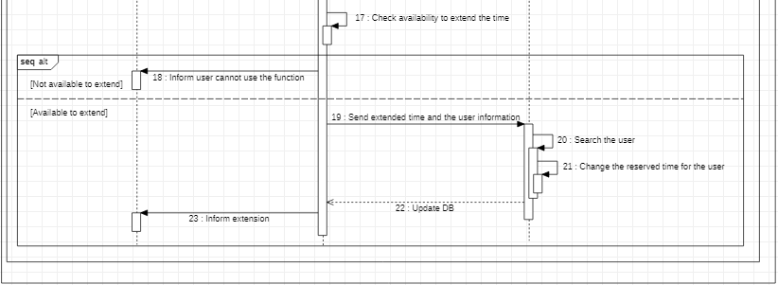

**<Check-Out(User)>**

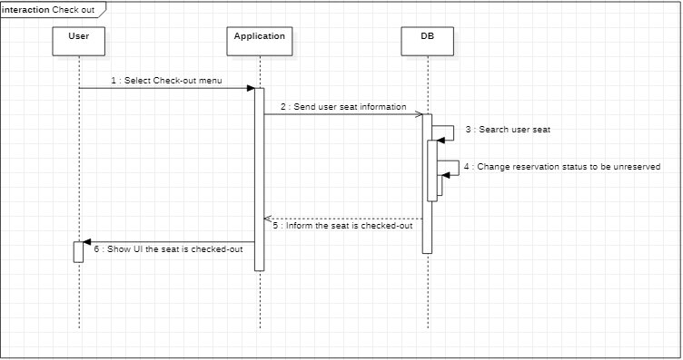

**<Check-Out(Admin)>**

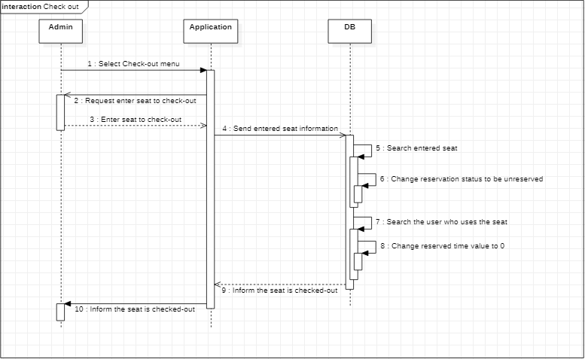

**<Set Time>**

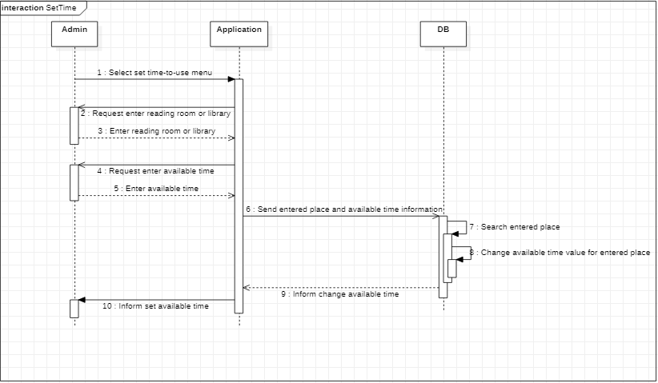

**Activity diagram**

**<Create Account>**

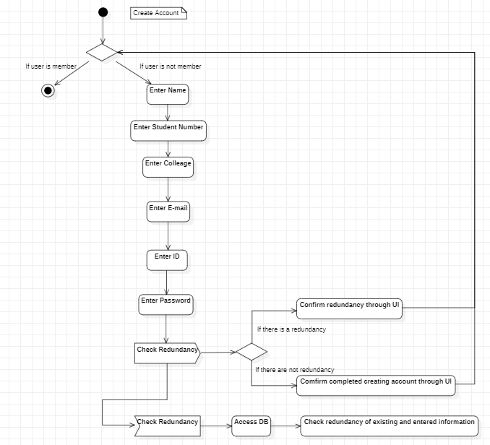

**<Login>**

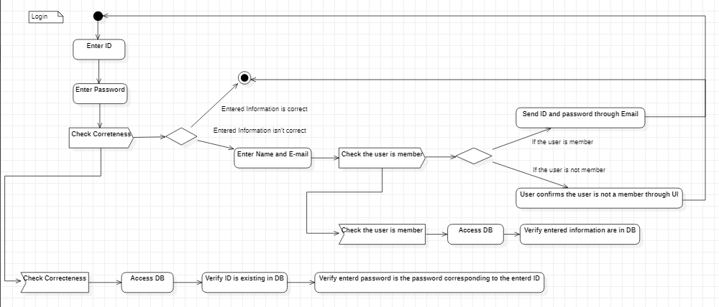

**<Reservation>**

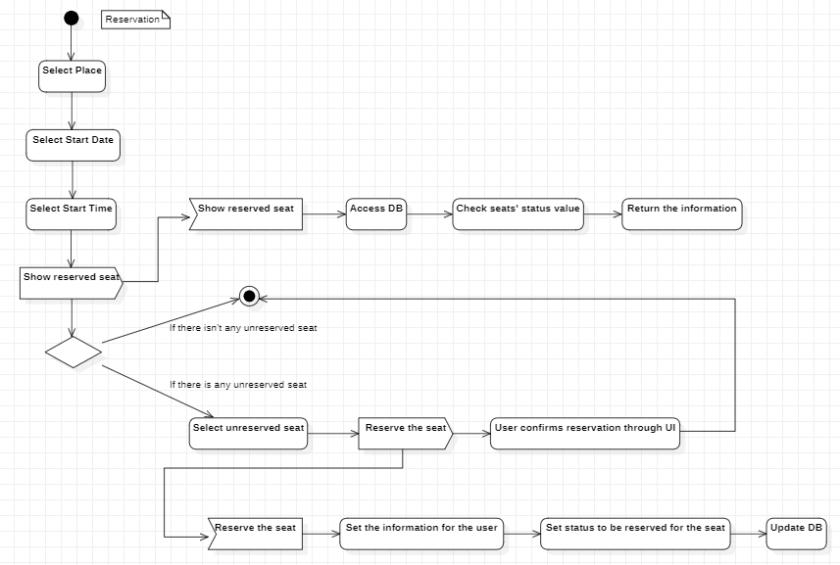

**<Extension>**

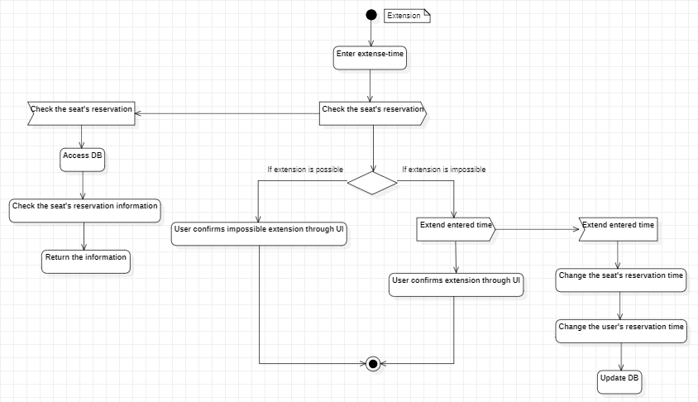

**<Out-Of-Office>**

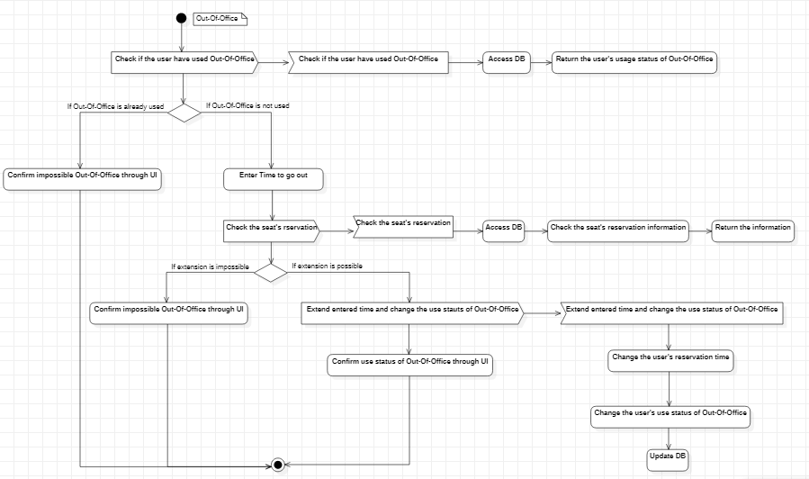

**<Check-Out(User)>**

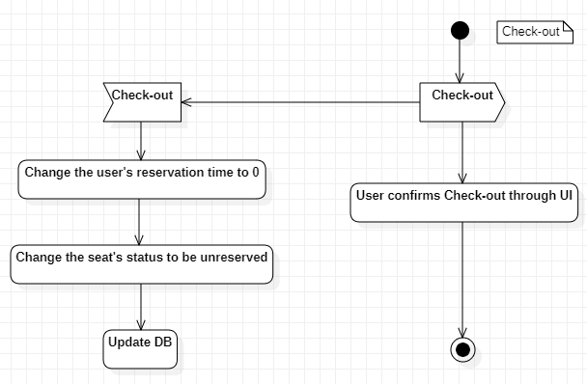

**<Check-Out(Admin)>**

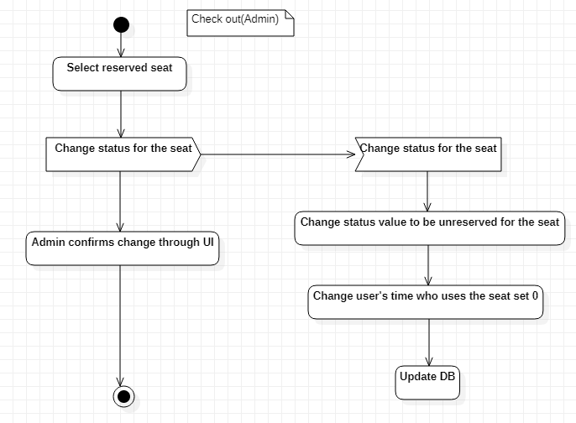

**5. Architecture**

**Architectural Design**

* An architectural model that describes how the system is organized as a set of communicating components.

<Architectural of system>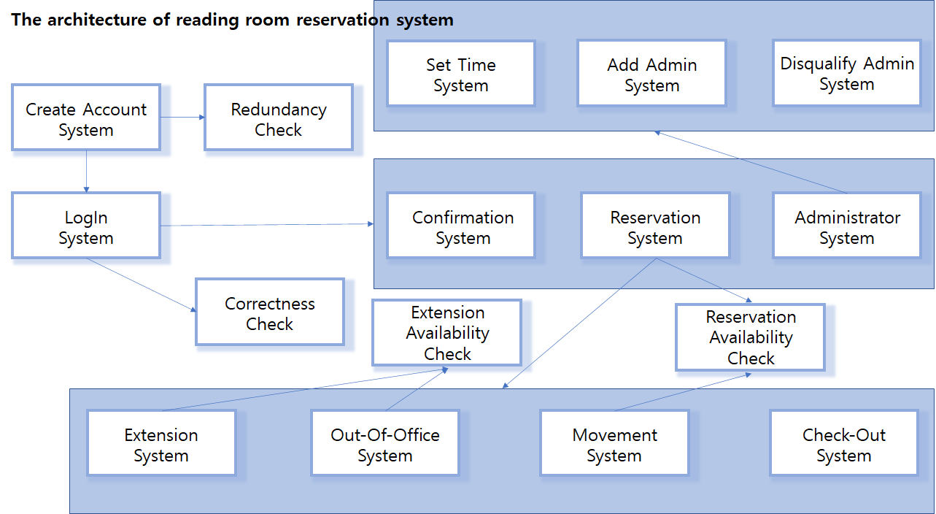

<A generic Layered pattern>

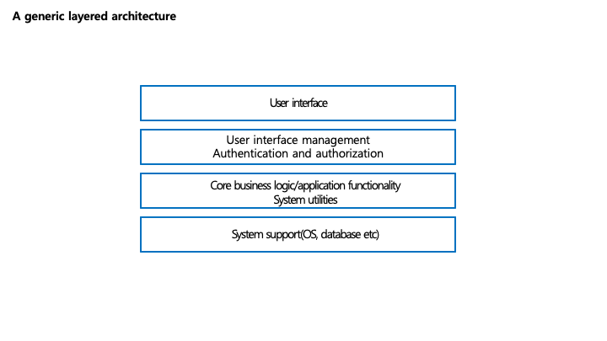

**<Layered pattern>**

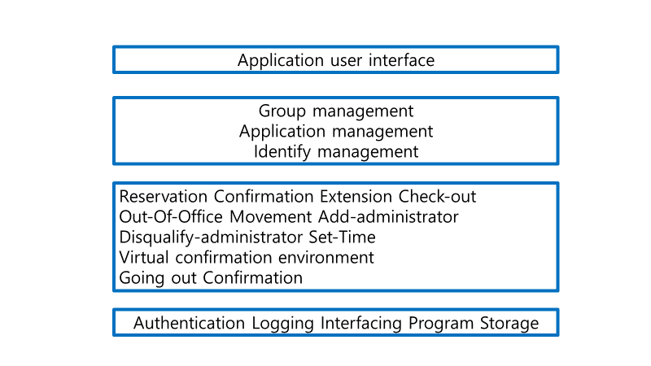

A physical view, which shows the system hardware and how software components are distributed across the processors in the system

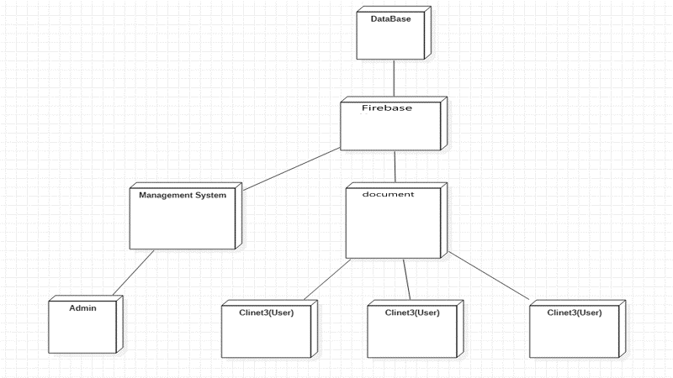

<Development View – Component Diagram>

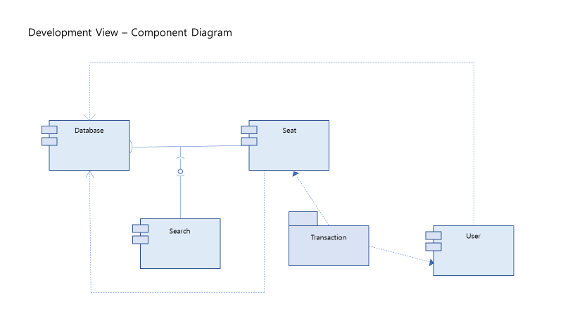

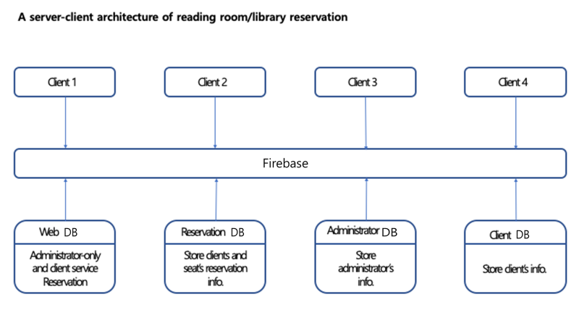

<MVC pattern>

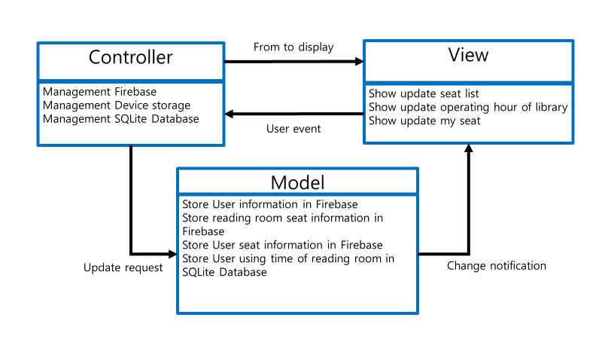

**<Repository pattern>**

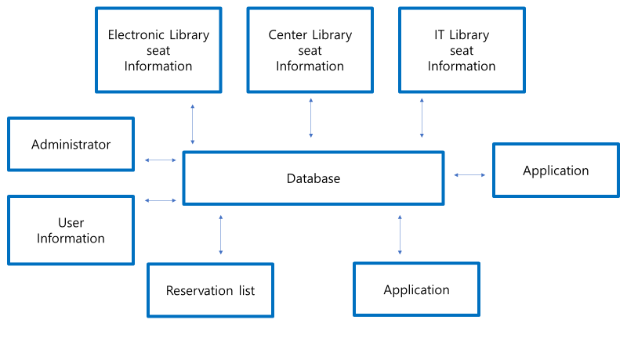

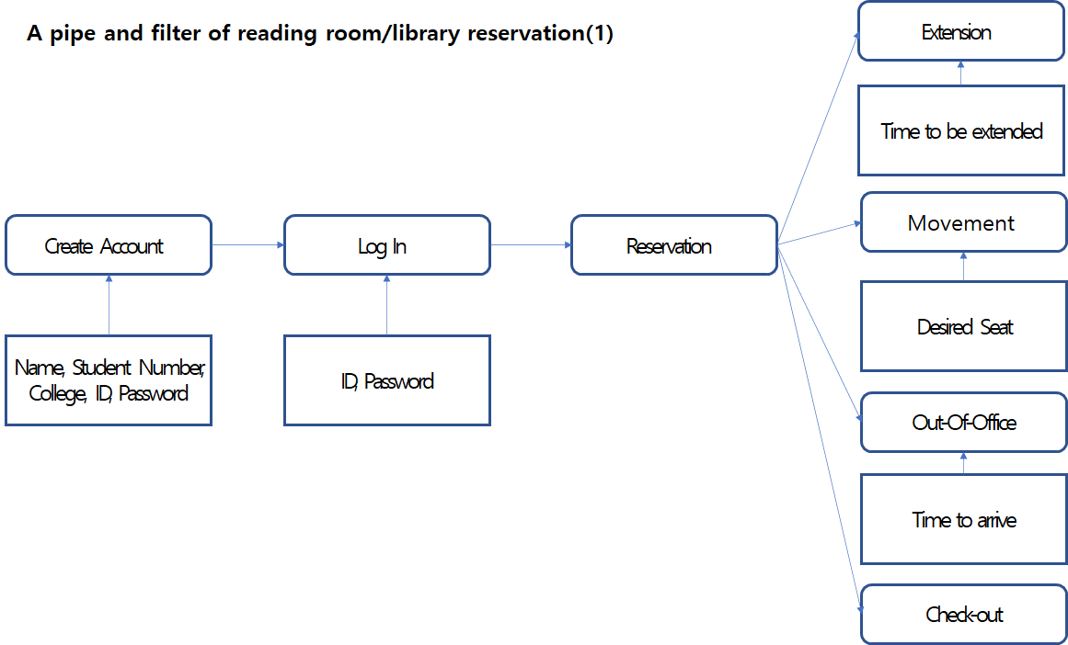

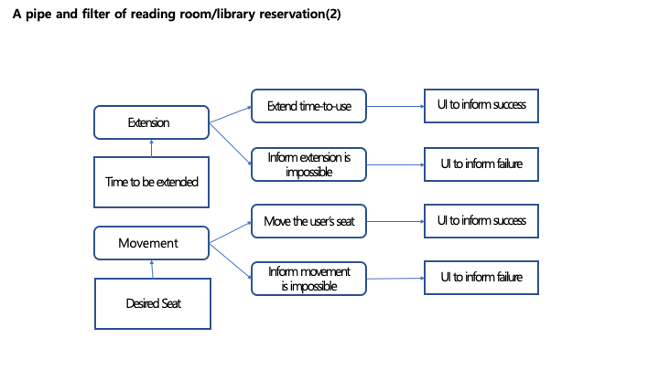

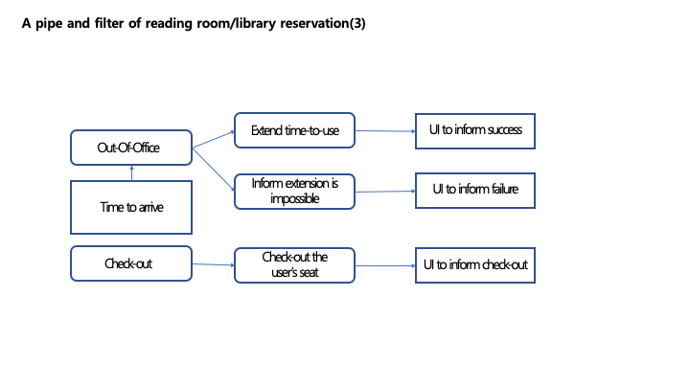

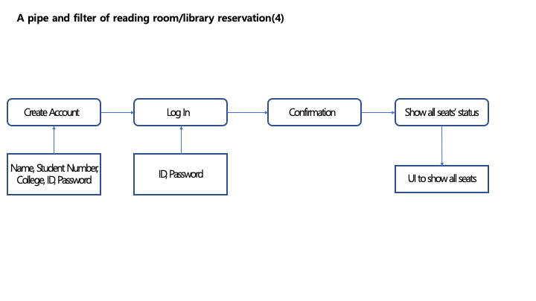

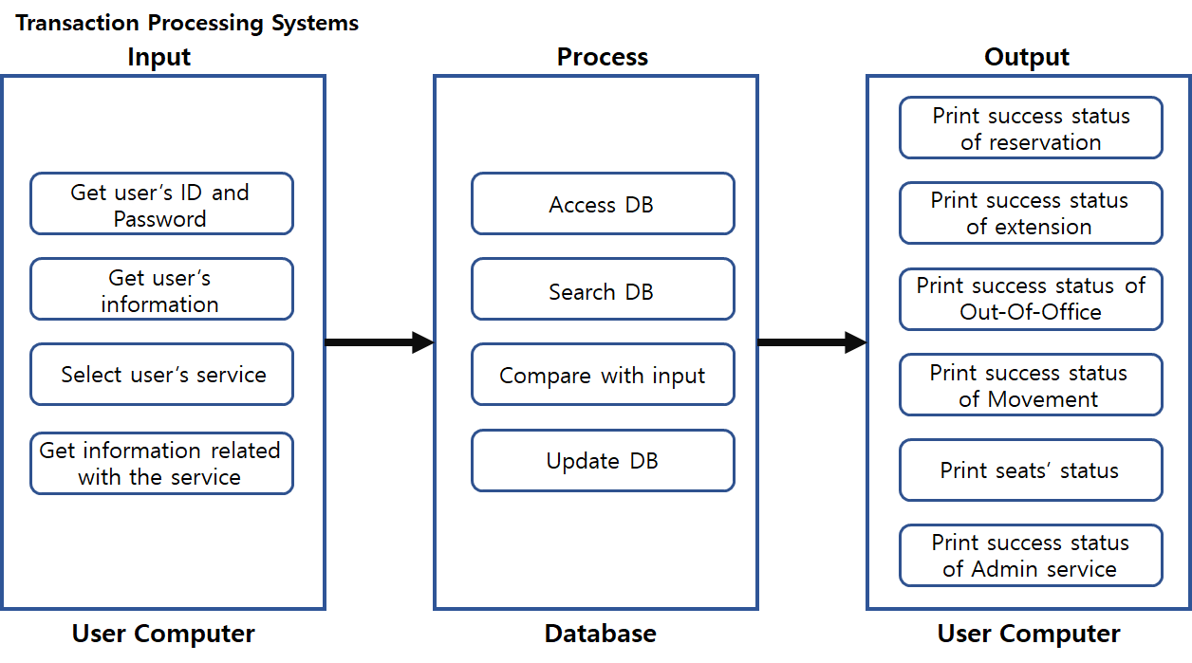

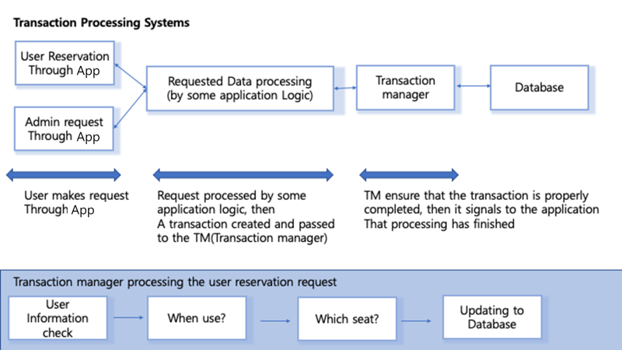

**6. System Implementation**

<Java file & layout file>

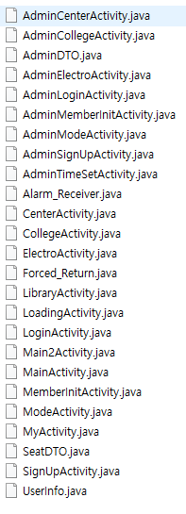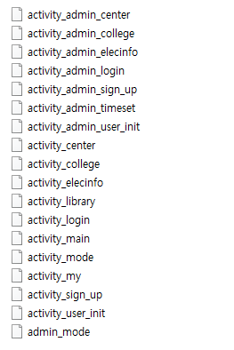

* Using Android Studio – APP(UI) & Using Firebase (DB)

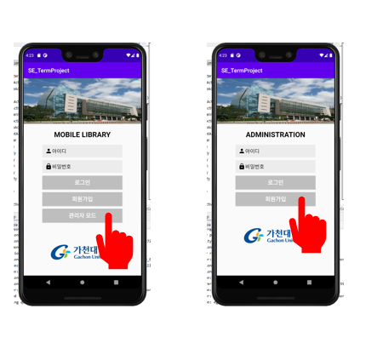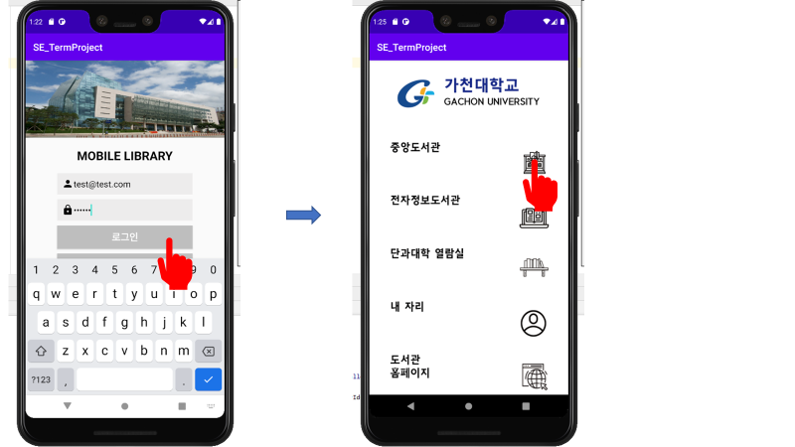

* The user first accesses the app through admin and general user log-in and sign-up and brings the DB details according to his or her information. Login and membership were implemented using the Firebase API. You can then select the reading room you want through the UI.

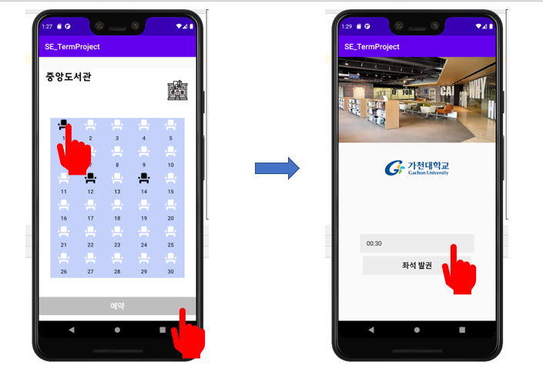

* Then select the seat you want in the selected reading room. At this time, the use of the seat was visualized and expressed. The status of each seat shall be indicated in white for the empty seat and black for the used seat using the seat information in the DB.

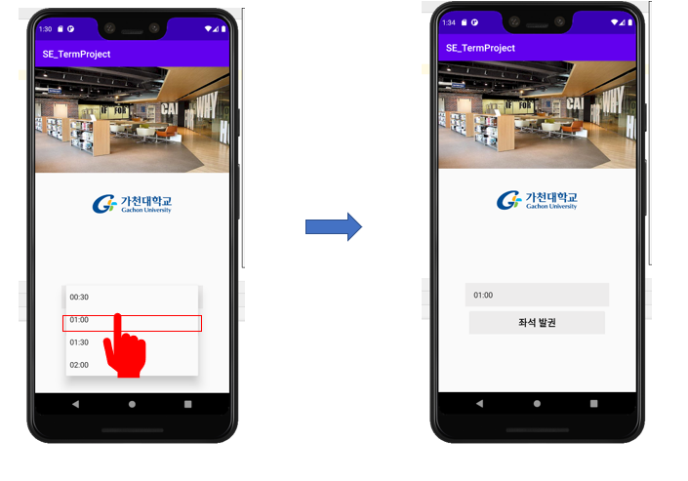

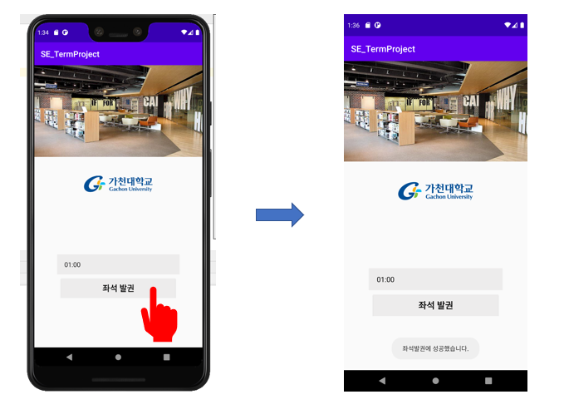

* After that, you can select the time zone by pressing the reservation button. Using Spinner, the time zone can be selected up to 30 minutes, 1 hour, 1 hour and a half, and 2 hours. Subsequently, using Intent, use the reading room information from the previous page, the seating information, and the time value to be used on the current page to update the DB history to reserve the seat.
* When a seat is booked, use the AlarmManager Api to store (current server time + hours to use) on its own server in the module and automatically return the seat when the time is set. At this time, use AlarmReceiver to run the app and return it when the app is not in use.

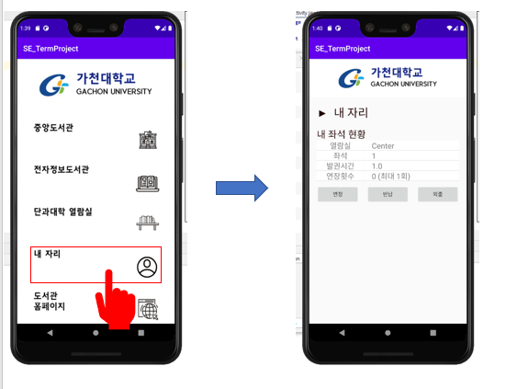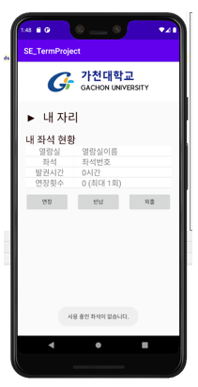

* Select 'My Seat' from the menu to view the current user's seat information. Invoke DB history first when running screen. If no seats are assigned in DB history, show the empty value, and if there are seats in use, call up the details and show them.
* If the seat is in use, the function of extension, return and out may be used. These functions can be extended by selecting 30 minutes and 1 hour, respectively, and only once during seat use. The return function allows the user to return the seat on their own before the closing time. The out-of-door function is similar to an extension and can be used only once when you want to go out.
* Update the extension function by adding the time of use stored in the DB and the time of completion of forced use stored in the module's own server.
* When using the return function, both the user DB and the reading room DB are initialized in the DB details. It also initializes the time stored on the module's own server.
* When using the out-of-door function, the status of the seat in the user DB and the reading room DB is changed to '2' so that the manager can know that the user is out when inquiring. In addition, the added time updates the FirebaseDB and the module's own servers in the same way as the extension function.

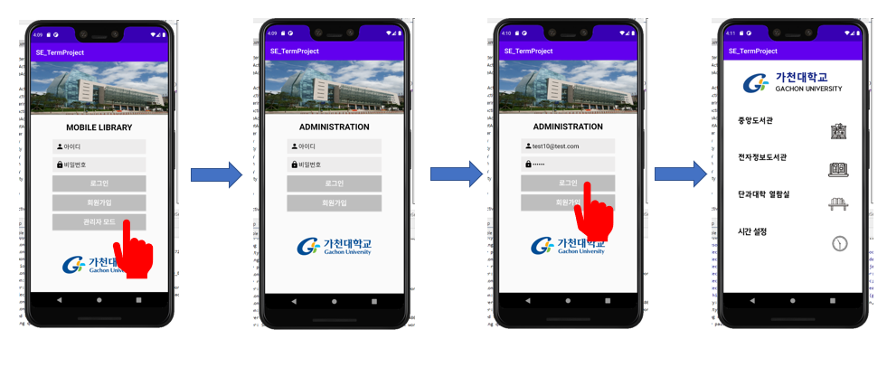

* Manager mode is a mode in which you can use the functions of managing seats in use in the library and adjusting library hours. The administrator can select the admin mode on the first screen and use it to log in or sign up as a member. The menu includes the inquiry and time settings for each reading room.

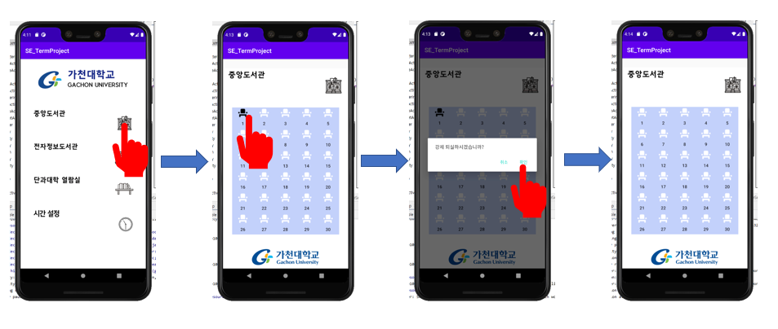

* When entering by selecting the reading room menu, FirebaseDB calls up the current seat status in real time, visualizes it, and provides it to the UI. If you select the seat you are using, you can force the seat to be returned. The DB of the selected seat and the user DB that was using the seat are also initialized.

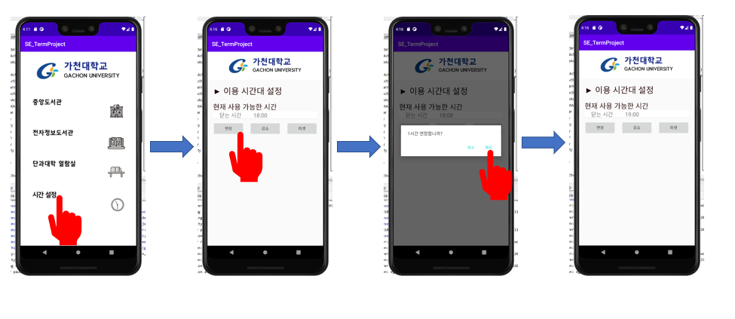

* The following is the time setting function. When the time setting is selected, the Default time is 18:00 when the currently available time is available. The time can then be adjusted using the extended, reduced and reset functions. The extension function increases the available time by 1 hour when clicked, and the reduction function reduces the available time by 1 hour when clicked. When the reset button is pressed, the default value can be initialized at 18:00.
* When a user makes a reservation for a seat, the user's return time, which is the value to be stored in AlarmManager, is not allowed to make a reservation if the time of the reading room is later than the time of closing.

**7. System Testing**

**Performance Testing**

* Android Profiler

* Data base Testing

**UI Testing**

* Espresso Test Recorder

**<**Login**>**

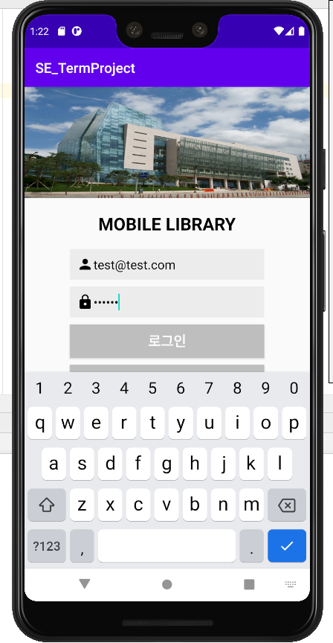 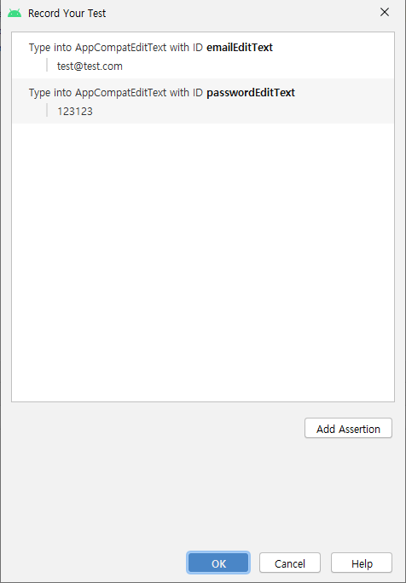

**<**Enter Center Library**>**

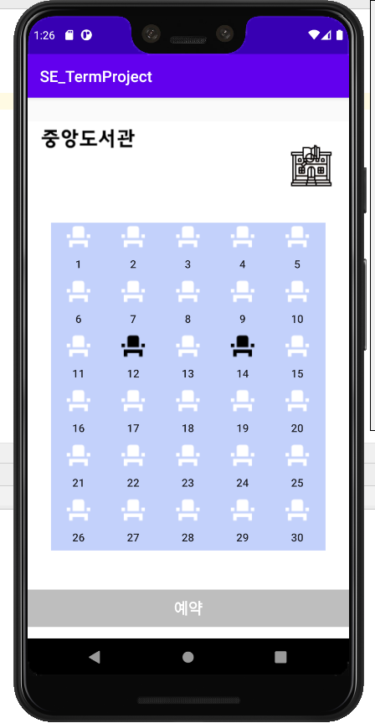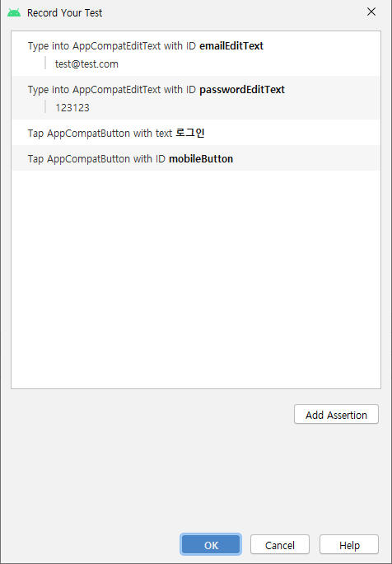

**<**Reservation>

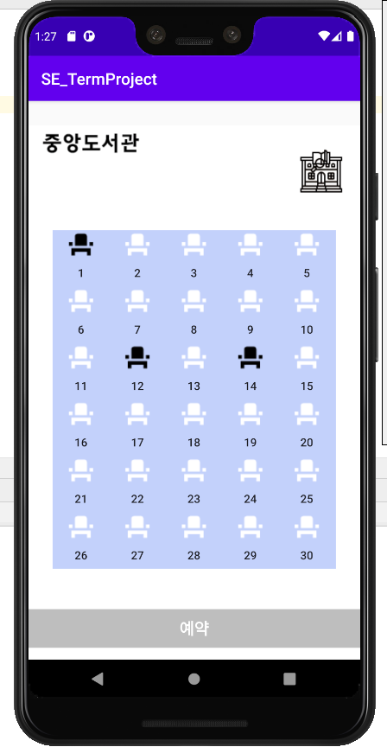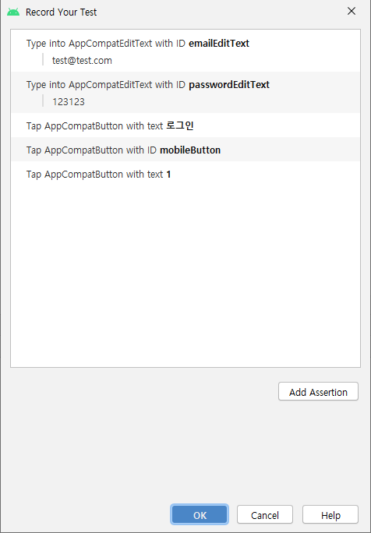

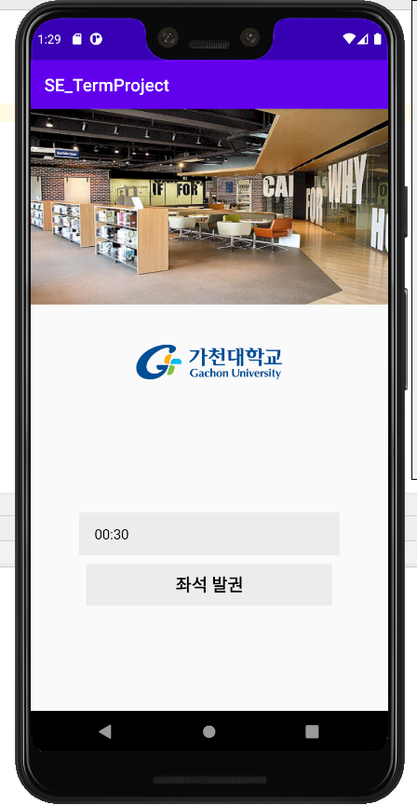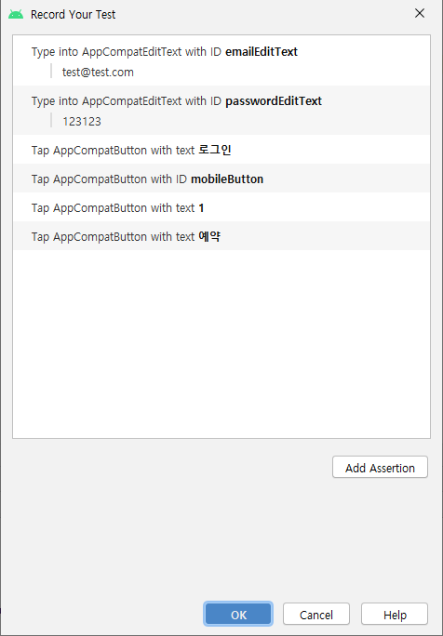

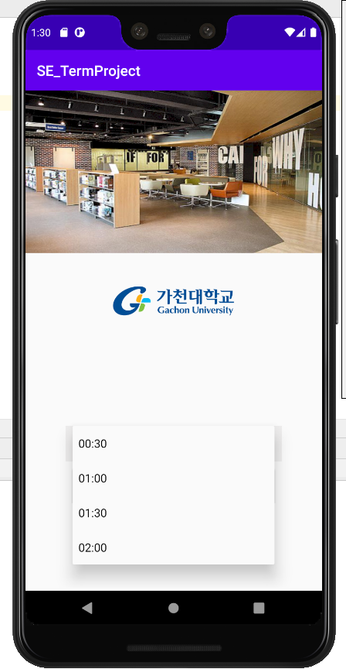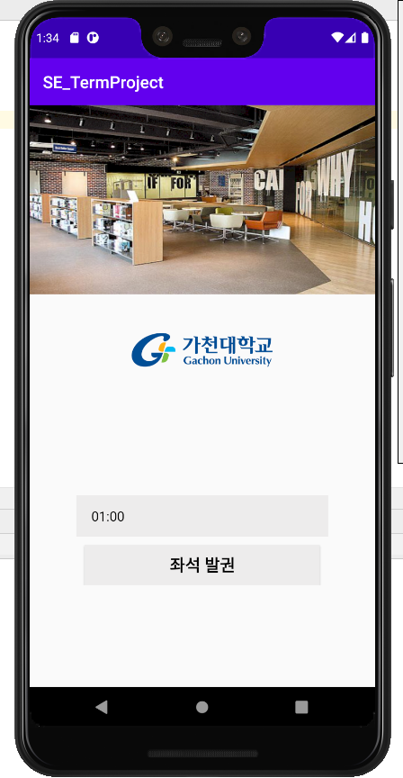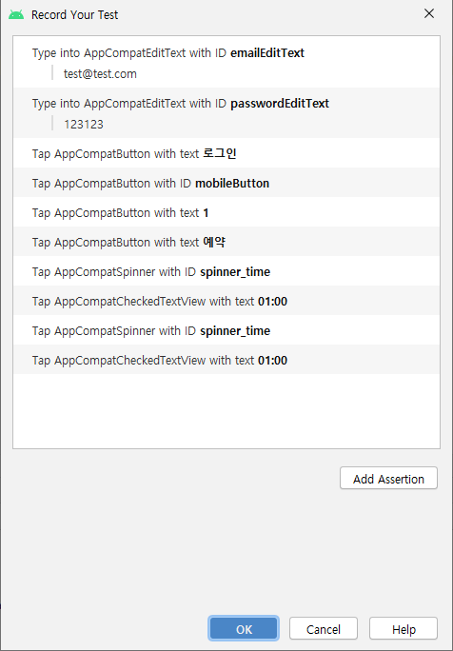

<Success Reservation>

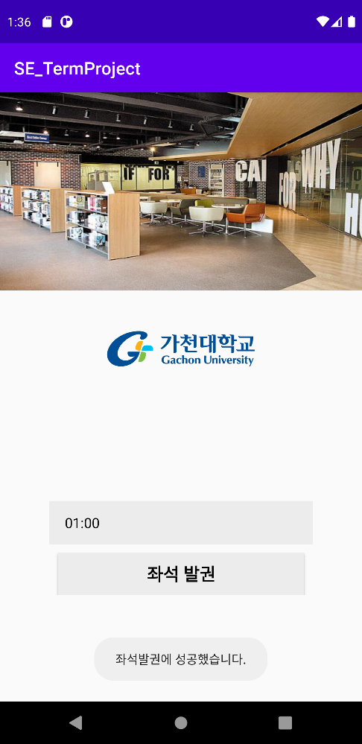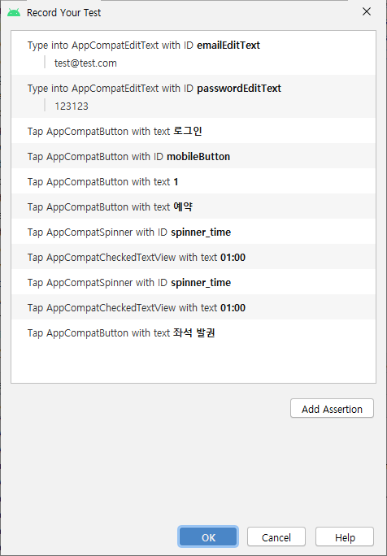

**<**Confirm seat’s status**>**

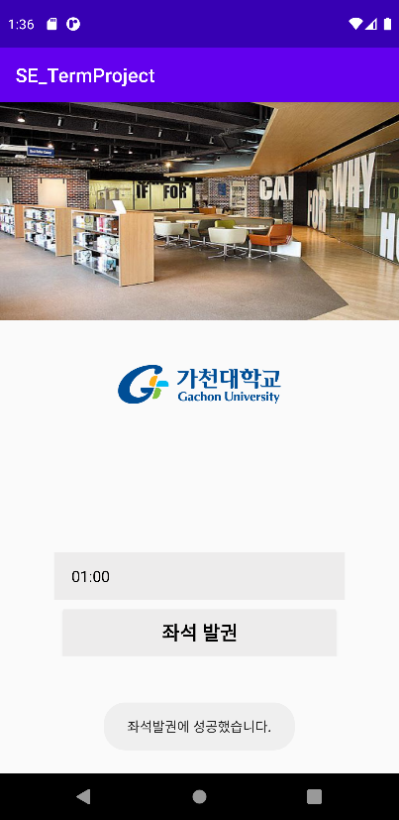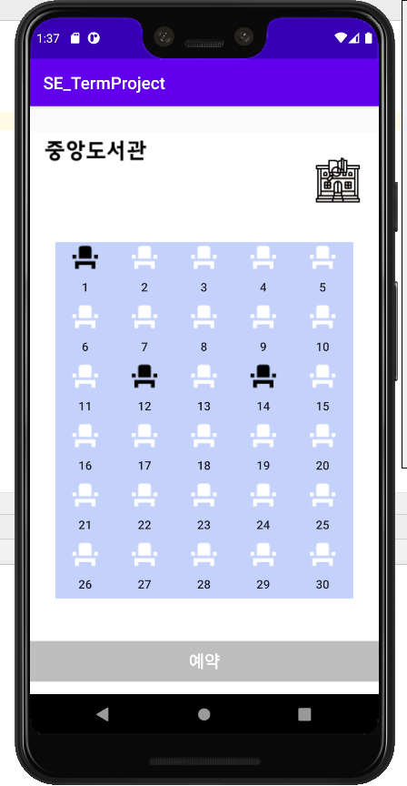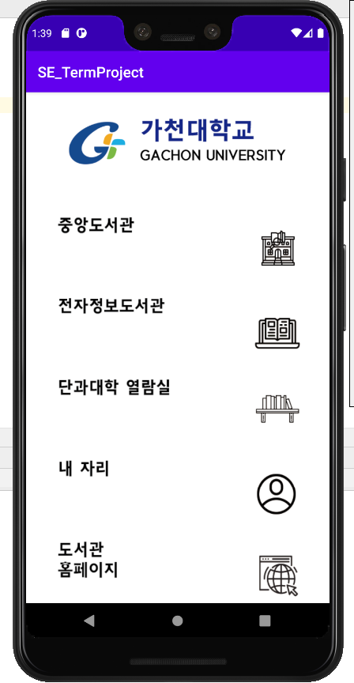

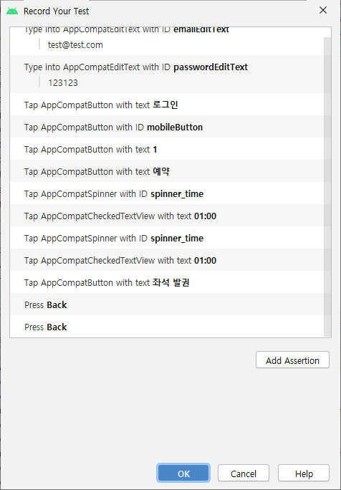

**<**My Seat>

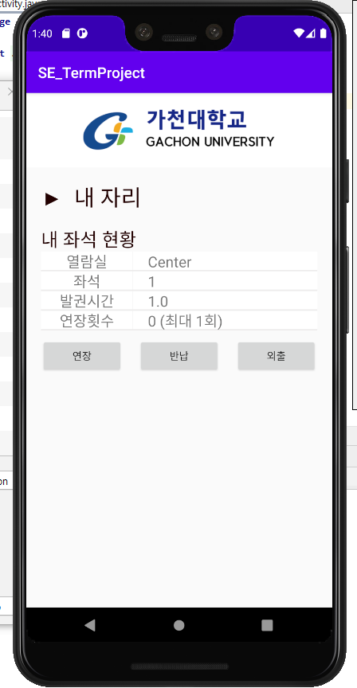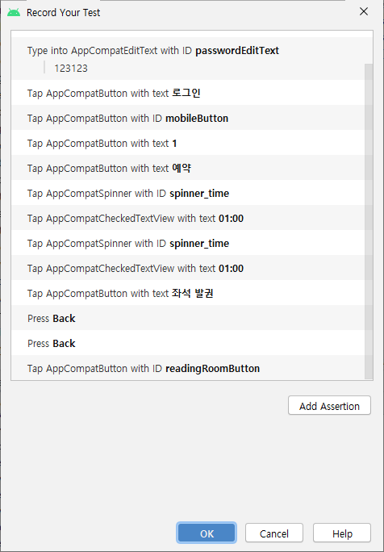

**<**Extension>

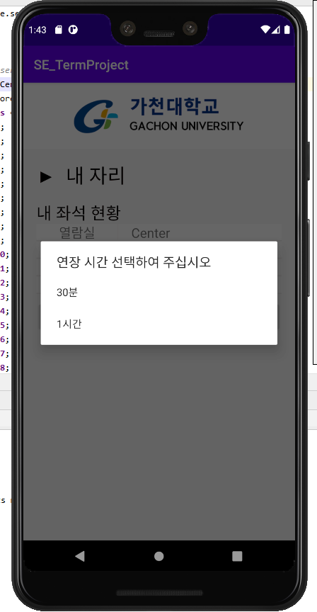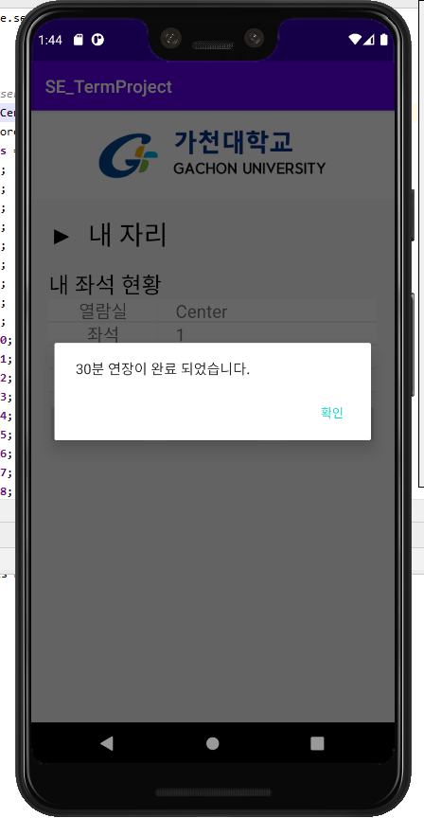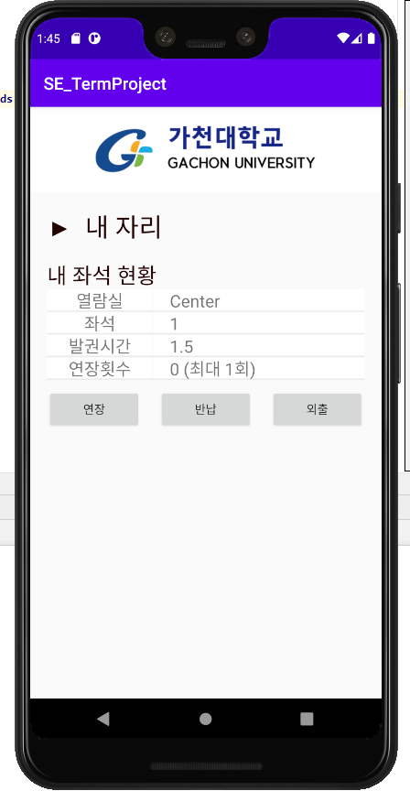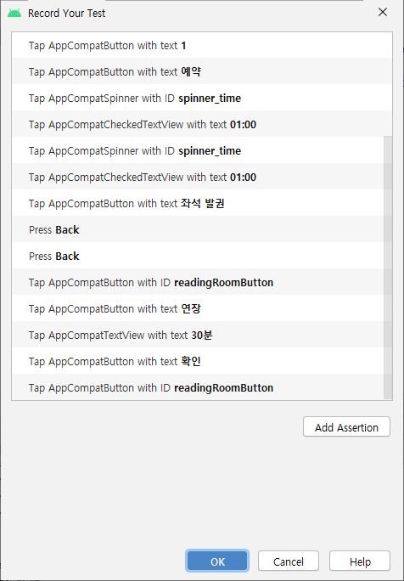

**<**Check-Out>

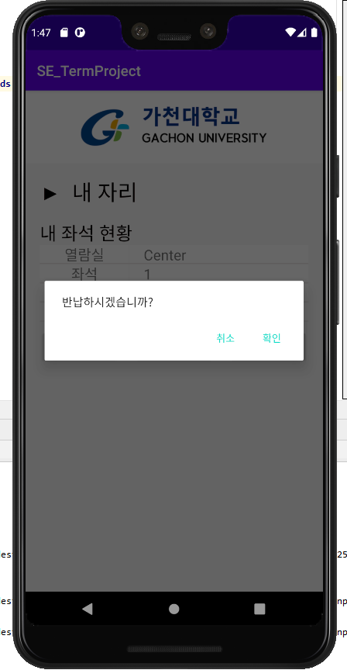

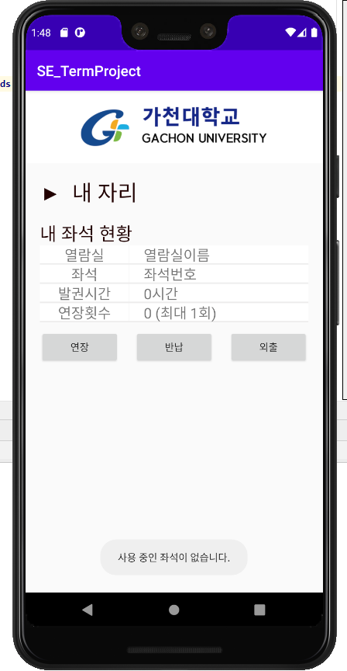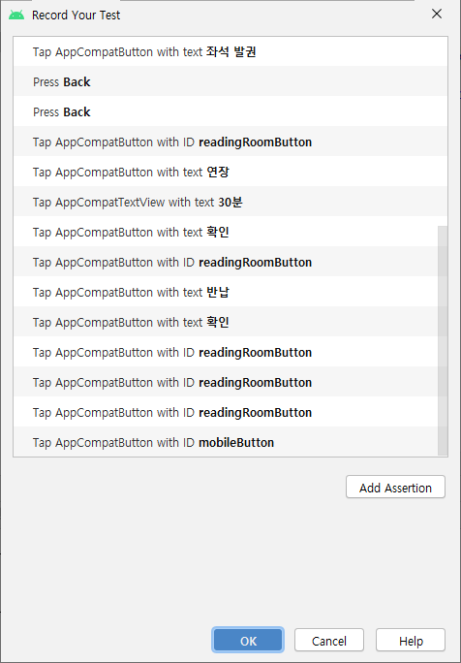

**<**Outing>

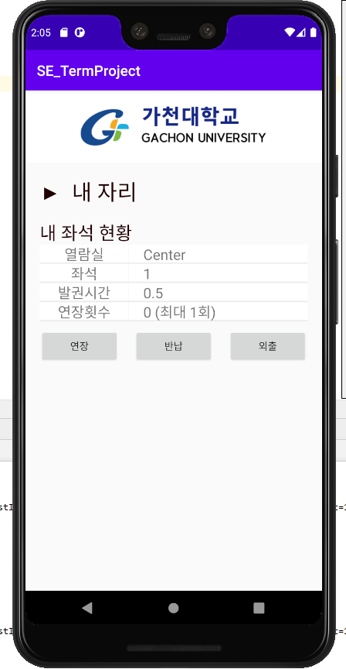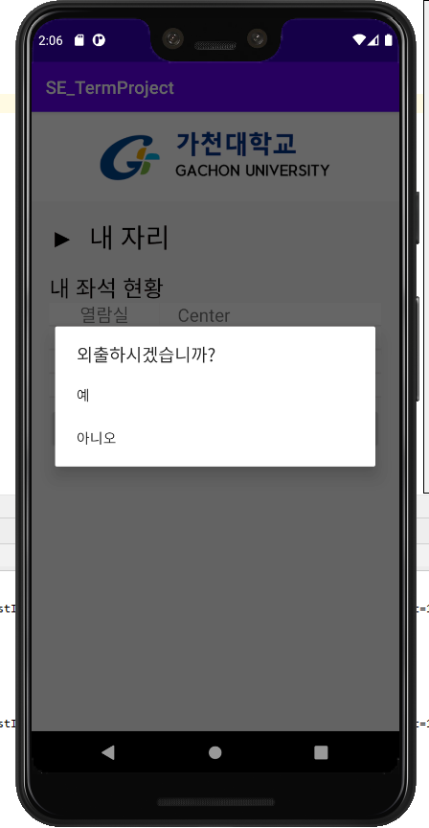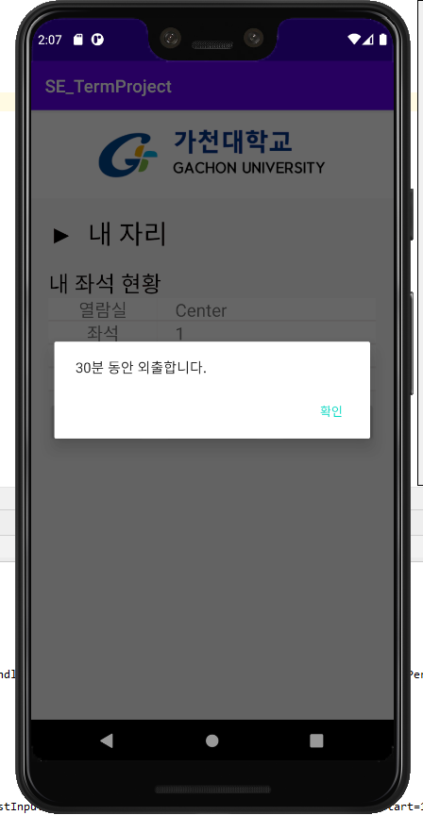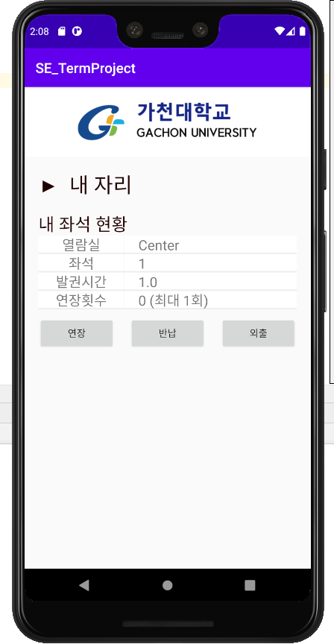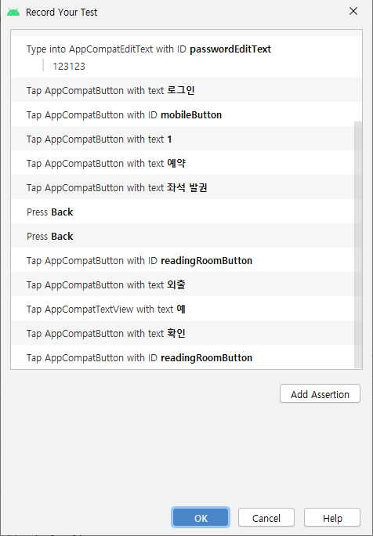

**<**Outing>

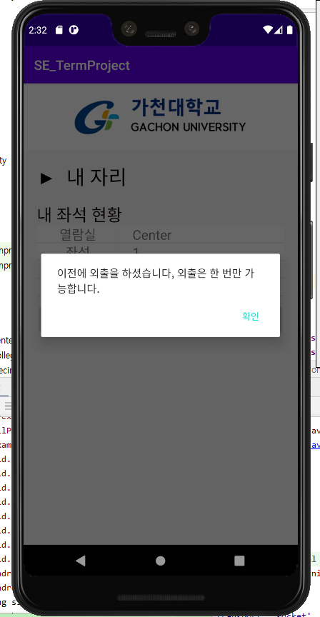

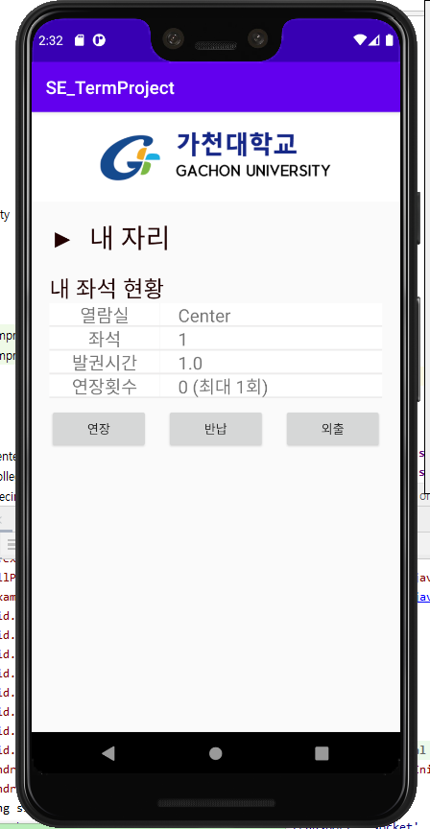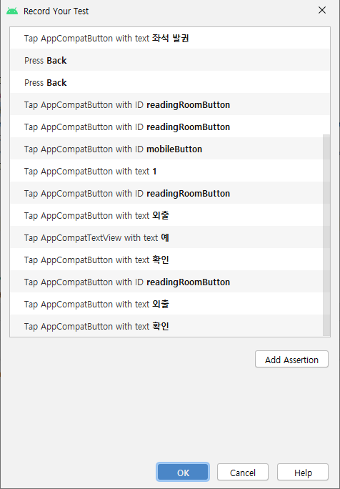

**<**LogIn(Admin)>

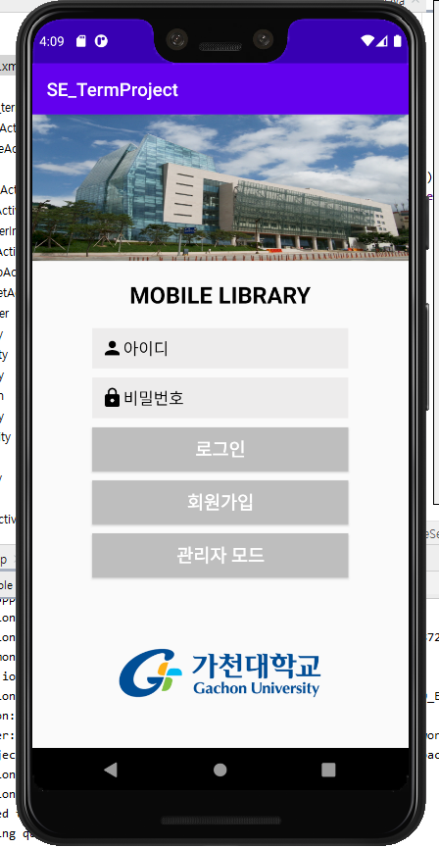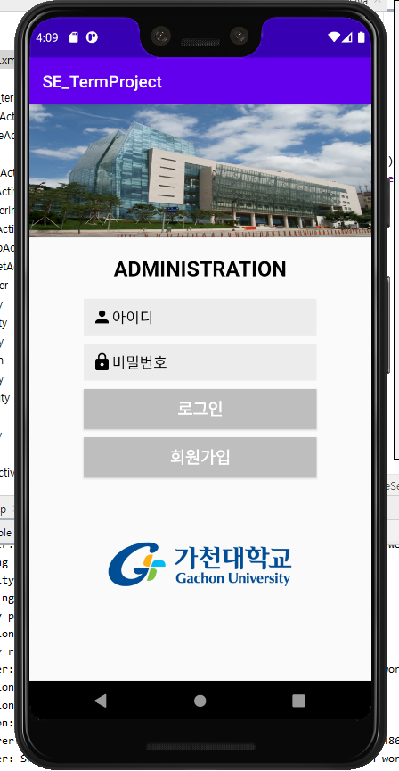

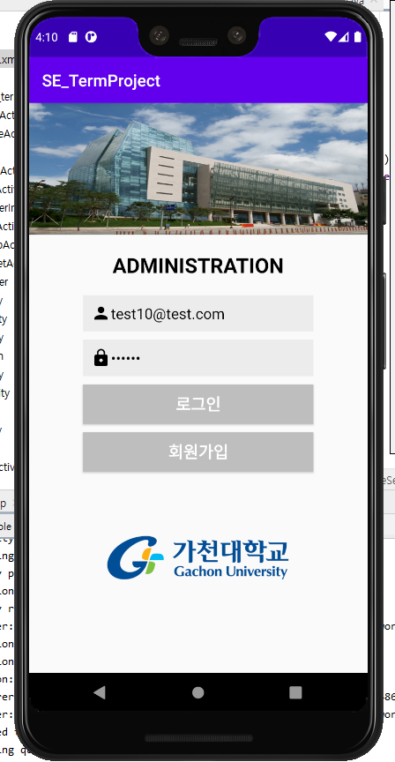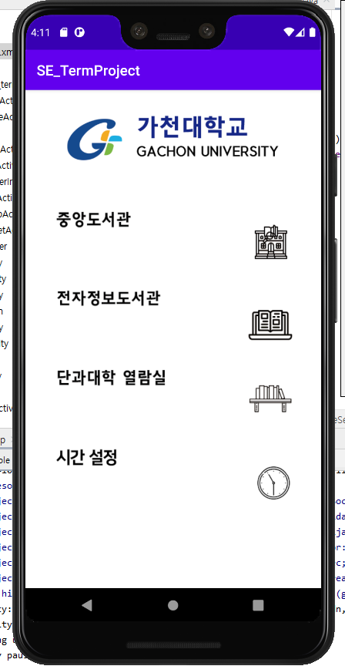

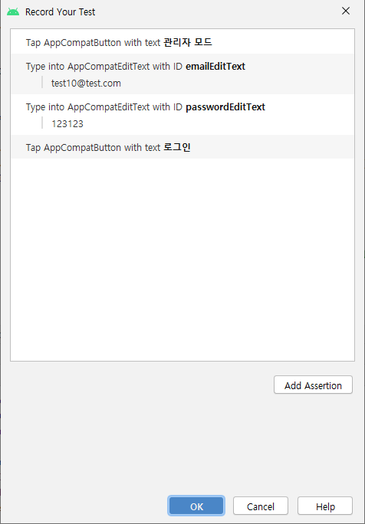

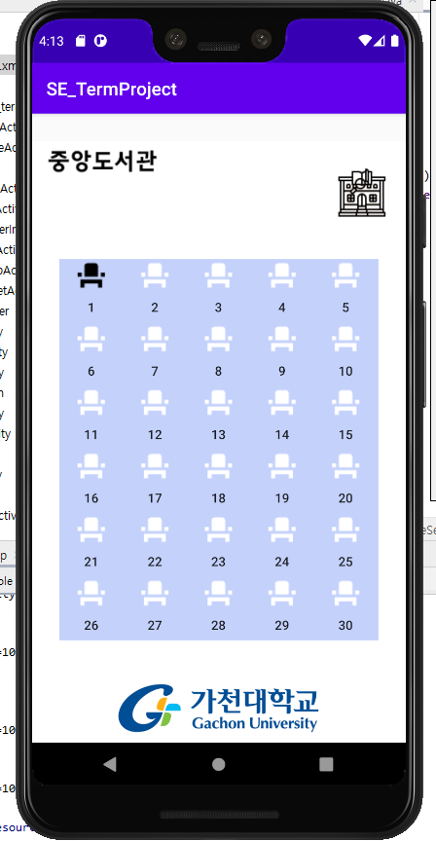<Check-Out(Admin)>

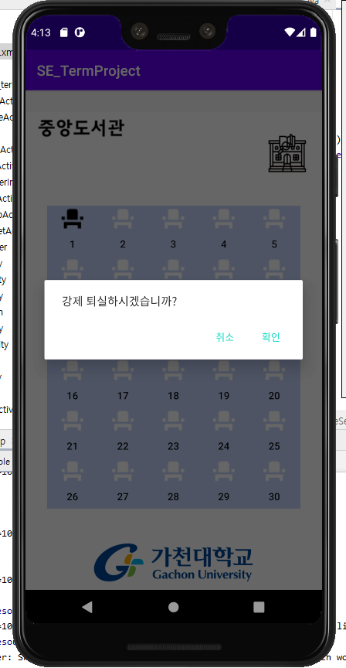

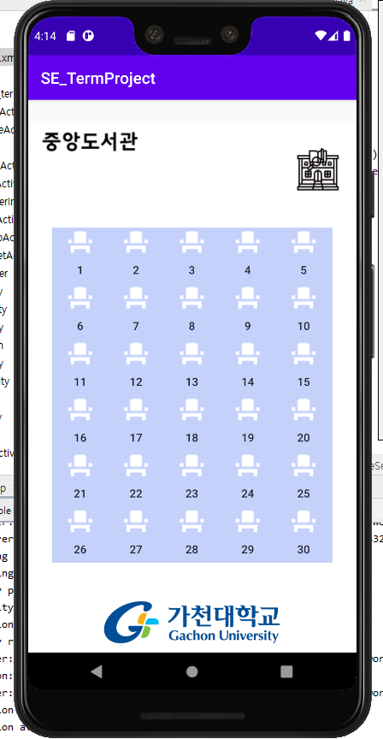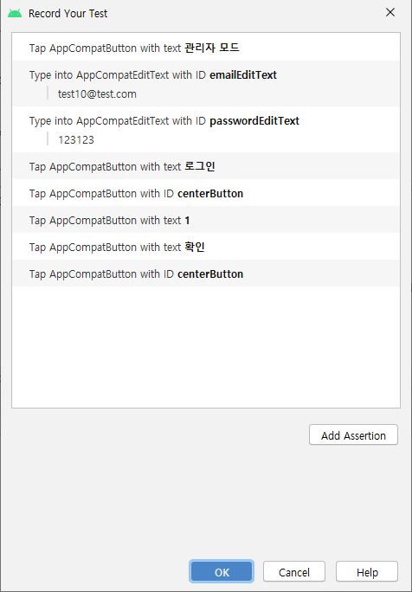

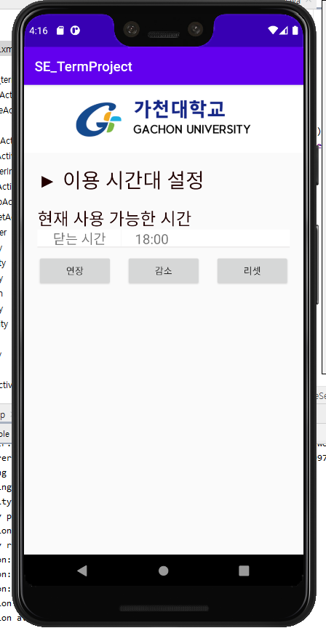<Set Time(Extension)>

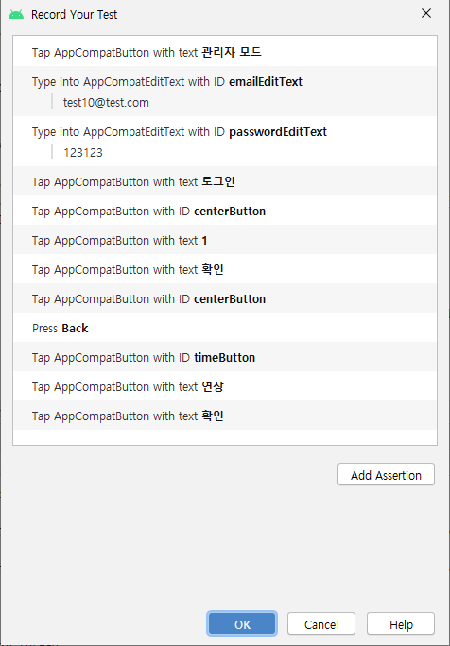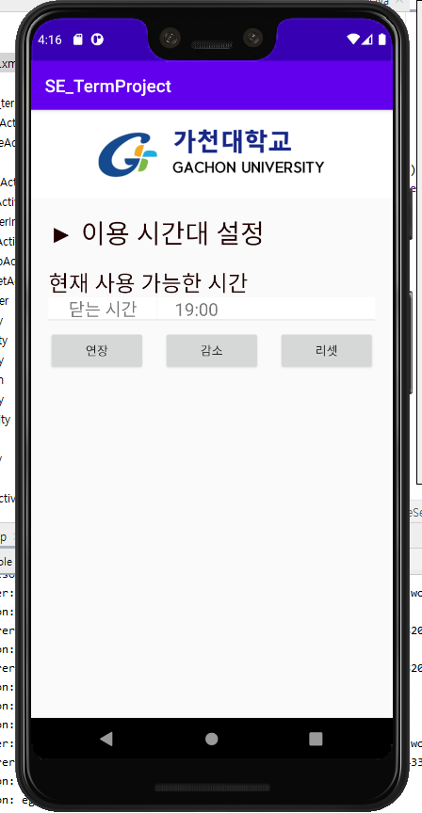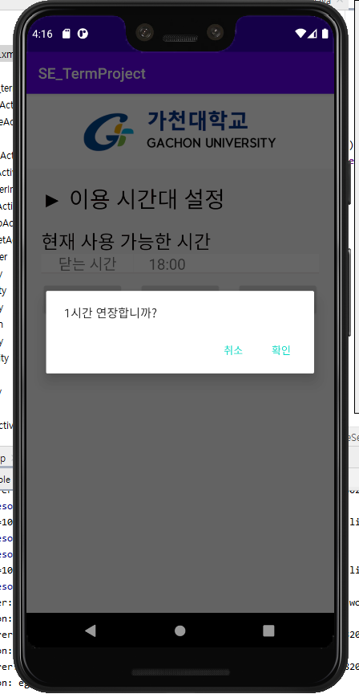

<Set Time(Reduction)>

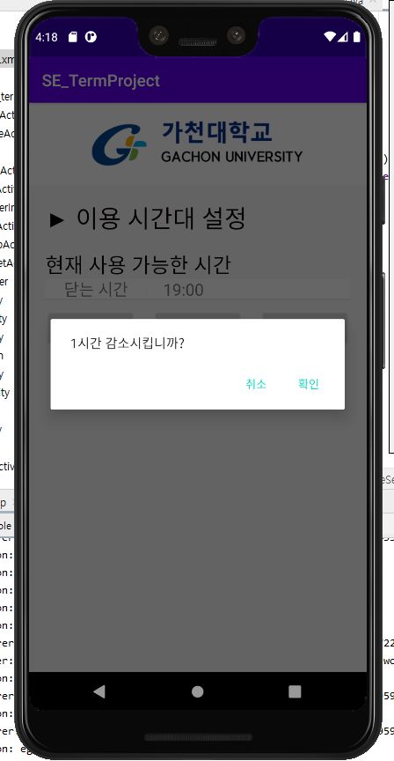

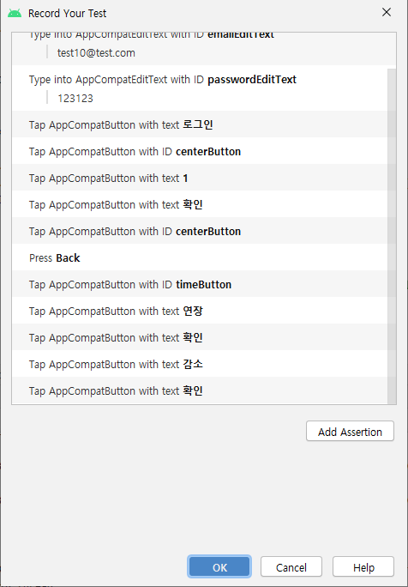

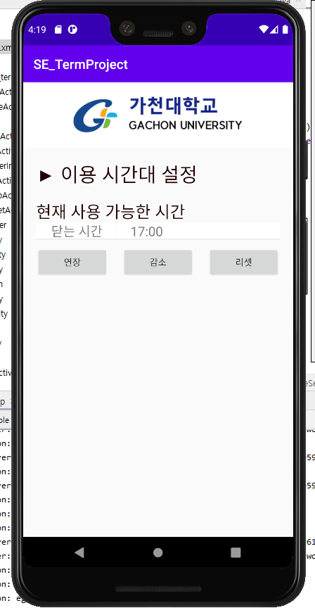<Set Time(Default)>

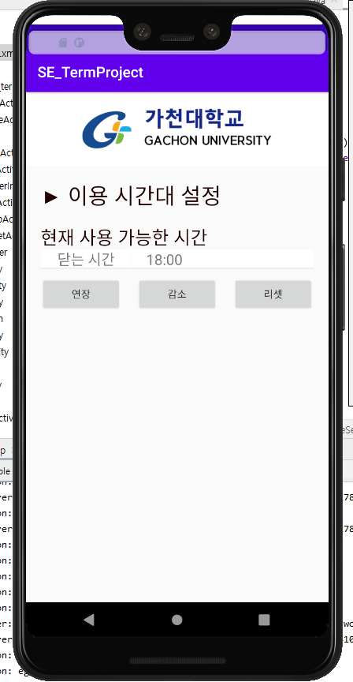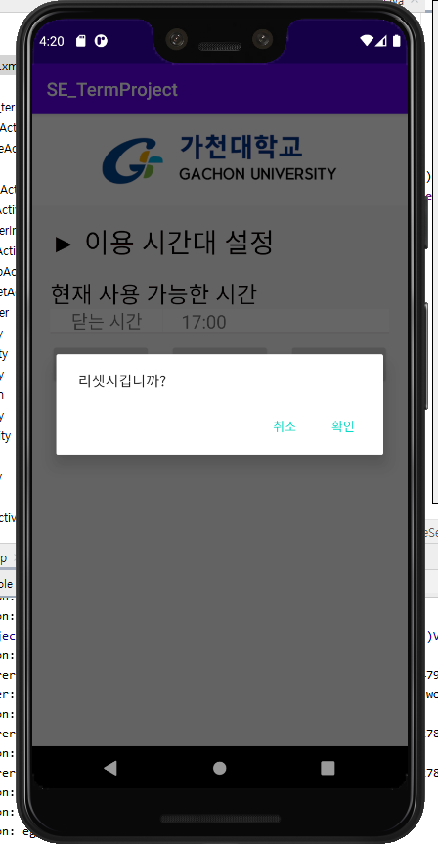

**Code Coverage**

* Junit

**Configuration**

* Github

**Documentation**

* Doxygen

